PIZZA SALES SQL QUERIES
KPI PIZZA
- Total Revenue: The sum of the total price of all pizza orders.
SELECT sum(total_price) as Total_Revenue
FROM pizza_sales;
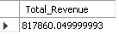
- Average Order Value: The average amount spent per order calculated by dividing the total revenue by the total number of orders.
SELECT sum(total_price) / COUNT(DISTINCT(order_id)) as Average_Order_Value
FROM pizza_sales;
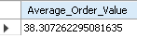
- Total Pizzas Sold: The sum of the quantities of all pizzas sold.
SELECT sum(quantity) as Total_Pizza_Sold
FROM pizza_sales_proper;
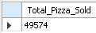
- Total Orders: The total number of orders placed.
SELECT COUNT(DISTINCT order_id) as Total_Order
FROM pizza_sales_proper;
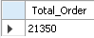
- Average Pizzas Per Order: The average number of pizzas sold per order, calculated by dividing the total number of pizzas sold by the total number of orders.
SELECT CAST(CAST(SUM(quantity) AS DECIMAL (10,2)) / CAST(COUNT(DISTINCT order_id) AS DECIMAL (10,2)) AS DECIMAL (10,2)) AS Average_Pizza_per_Order
FROM pizza_sales_proper;
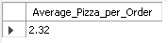
6.Daily Trend for Total Orders:
SELECT dayname(ORDER_DATE) AS order_day, COUNT(DISTINCT order_id) AS total_orders
FROM pizza_sales_proper
GROUP BY dayname(order_date)
order by total_orders desc;
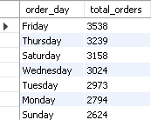
7.Monthly Trend for Total Orders:
SELECT monthname(order_date) as Order_month, COUNT(DISTINCT order_id) as total_orders
FROM pizza_sales_proper
GROUP BY monthname(order_date)
ORDER BY total_orders DESC;
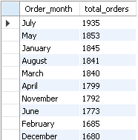
8.Percentage of Sales by Pizza Category:
select pizza_category, sum(total_price) as total_sales, cast((sum(total_price)) * 100 / (select sum(total_price) from pizza_sales_proper) as decimal (10,2)) as percentage_of_sales
from pizza_sales_proper
group by pizza_category
order by percentage_of_sales desc;
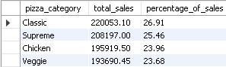
9.Percentage of Sales by Pizza Size:
select pizza_size, cast(sum(total_price) as decimal(10,2)) as total_revenue, cast(sum(total_price) * 100 / (select sum(total_price) from pizza_sales_proper) as decimal (10,2)) as percentage_of_sales
from pizza_sales_proper
group by pizza_size
order by percentage_of_sales desc;
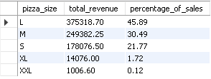
10.Total Pizzas Sold by Pizza Category:
select pizza_category, sum(quantity) as Total_Pizza_sold
from pizza_sales_proper
group by pizza_category;
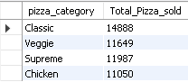
11.Top 5 Best Sellers by Total Pizzas Sold:
select pizza_name, sum(quantity) as Total_sold
from pizza_sales_proper
group by pizza_name
order by total_sold desc
LIMIT 5;
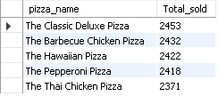
12.Bottom 5 Worst Sellers by Total Pizzas Sold:
select pizza_name, sum(quantity) as Total_sold
from pizza_sales_proper
group by pizza_name
order by total_sold asc
LIMIT 5;
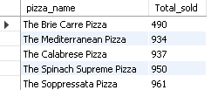
10. Top 5 Best Sellers by Revenue,
select pizza_name, sum(total_price) as revenue
from pizza_sales_proper
group by pizza_name
order by revenue desc
limit 5;
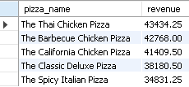
Total Sold,
select pizza_name, sum(quantity) as Total_sold
from pizza_sales_proper
group by pizza_name
order by total_sold desc
LIMIT 5;
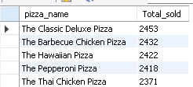
and Total Orders:
select pizza_name, count(distinct(order_id)) as total_order
from pizza_sales_proper
group by pizza_name
order by total_order desc
limit 5;
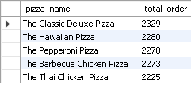
11. Bottom 5 Best Sellers by Revenue,
select pizza_name, sum(total_price) as revenue
from pizza_sales_proper
group by pizza_name
order by revenue asc
limit 5;
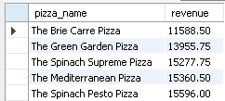
Total Sold,
select pizza_name, sum(quantity) as Total_sold
from pizza_sales_proper
group by pizza_name
order by total_sold asc
LIMIT 5;
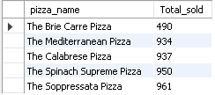
and Total Orders:
select pizza_name, count(distinct(order_id)) as total_order
from pizza_sales_proper
group by pizza_name
order by total_order asc
limit 5;
